

Project Assignment
Empirical Project: SSH Security Weakness Study

Course: Cyber Security

Ljubljana, 2/6/2026 Vishnu Viswanath Thattrakkal
Student ID- 35250024

Contents
Abstract 3
1 INTRODUCTION 4
2. Methodology 4
2.1 Tools and software 6
3 Experiment 6
3.1Reconnaissance 8
3.2Run brute-force attack 9
3.2.1 Configuration: A weak password, no protection 9
3.2.2 Configuration: B medium password, No protection 10
3.2.3 Configuration: strong password, no protection 10
3.2.4 Configuration: strong password+ rate limiting (fail2ban) 11
3.3 Effectiveness of Defensive Mechanisms 13
4 Discussion 14
5 recommendations 14
6 conclusion 14

Abstract

This report presents an empirical evaluation of SSH service resilience against automated brute-force attacks within a controlled Docker-based laboratory environment. The study investigates the impact of password complexity and defensive security mechanisms on authentication security by analysing three experimental configurations: a weak password without protection, a strong password without protection, and a strong password protected using fail2ban.
The experiments demonstrate that weak credentials are highly susceptible to automated password-guessing attacks, whereas strong passwords significantly increase resistance by extending the time required for an attack and reducing the likelihood of successful compromise. Additionally, implementing fail2ban enhances security by detecting repeated failed authentication attempts and temporarily blocking malicious sources, thereby limiting the effectiveness of brute-force attacks.
The findings emphasise the importance of layered security practices, including strong password policies, adaptive intrusion prevention mechanisms, and SSH hardening techniques such as key-based authentication. Overall, the study highlights how combining preventive and reactive defences can substantially improve the security posture of SSH services against automated threats.

Keywords: SSH, brute-force attack, password security, fail2ban, Hydra, Nmap, network security, rate limiting, key-based authentication

1 INTRODUCTION
Secure Shell (SSH) is among the most prevalent protocols utilised for managing remote servers. Although it is built on robust cryptographic principles, SSH setups still face a significant risk from one of the most straightforward attack methods: brute-force password attempts.
This document outlines a practical examination of SSH security across various settings. The primary aim is to assess how the resilience against automated login attempts is affected by password complexity and protective strategies like rate limiting.
The study takes place in a controlled Docker environment to guarantee safe and ethical testing practices.
Objective
The objective of this project is to develop an understanding of SSH authentication mechanisms and the techniques used in brute-force attacks while evaluating how password strength influences system security. The project also aims to provide practical experience in configuring and testing defensive security mechanisms, collecting and interpreting empirical data, and developing evidence-based recommendations to improve cybersecurity and protect SSH services against automated attacks.

2. Methodology
The experiments were conducted in a controlled laboratory environment using Docker containers. A preconfigured SSH server was deployed locally to ensure that all attacks were performed on an isolated system without affecting external networks or services.
A containerised testing environment was established with Docker Compose. The SSH service was then initialised by executing the following command:
docker compose up -d
After the SSH container had been successfully started, the account-generation script was run inside the container to create the user accounts required for the security assessment. The script was executed using the following commands:
docker exec -it ssh_lab bash
/create_users.sh
Since the create_users.sh script already had executable permissions; it was executed directly within the container. This process created the three user accounts used throughout the experiments: weak user, medium user, and strong user. The successful creation of these accounts was verified by inspecting the user list inside the container.

Subsequently, Nmap was used to verify that the SSH service was running and accessible on port 2222, as well as to identify the service version. The following scan command was executed:
nmap -sS -sV -p 2222 localhost
The same method was used for the strong account to compare how password strength affects the result. I noted whether the login was successful, how long the attack took, and how many attempts were needed.
For the protected configuration, fail2ban was enabled to limit repeated failed SSH logins from a single source. A standard SSH jail configuration was used with a low retry threshold to simulate rate-limiting behaviour:
[sshd]
enabled = true
port 2222
maxretry = 3
bantime = 3600
findtime = 600
Fail2Ban status information and log records were reviewed to confirm the detection and blocking of repeated failed login attempts. The results were used to assess how rate-limiting controls affect automated brute-force attack activity and overall attack success.

2.1 Tools and software
The following tools were used throughout the experiment.
Tool | Purpose | Version
Nmap | Network scanning, SSH service fingerprinting | 7.94
Hydra | Automated brute-force/dictionary attacks against SSH | 9.5
Fail2ban | Intrusion prevention via IP banning after failed attempts | 1.0.2
Open SSH server | Target SSH service running inside a Docker container | 8.9p1
Docker | Containerised isolation of the lab environment | 24.0
Python 3.11 | Wordlist generation and timing analysis scripts | 3.11
Table -1

3 Experiment
Three user accounts were provisioned on the SSH server to support the three experimental configurations:
Username | Password | Complexity | Purpose
weakuser | 123456 | Easy to crack | Configuration A – Weak password, no protection
mediumuser | Password123 | Moderate | Reference / intermediate comparison
stronguser | Str0ng!Pass#2026 | Hard to crack | Configurations B &  C – Strong password
Table -2
The accounts were created using a provisioning script (create_users.sh) copied into the container via docker cp and executed with root privileges. The strong password satisfies all four major complexity criteria: uppercase letters, lowercase letters, digits, and special characters.
docker exec -it ssh_lab bash
chmod +x /create_users.sh
/create_users.sh

Three configurations were tested in sequence. Between each test, the fail2ban ban list was flushed (where applicable) and the SSH service was restarted to ensure a clean baseline. The password wordlist (passwords.txt) used for all Hydra attacks was constructed.
Run this to add these additional users for the experiment.
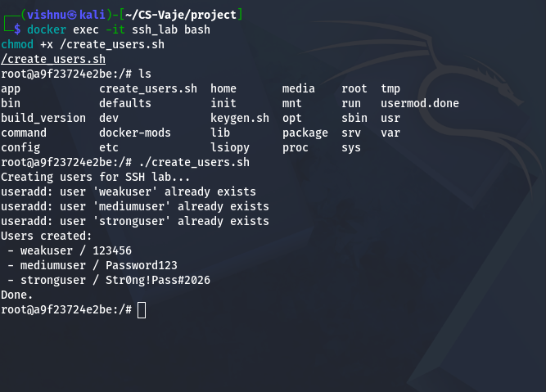
IMAGE 1

Connect to the SSH server
ssh student@localhost -p 2222
Default credentials:
- Username: student
- Password: password123
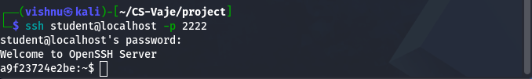
IMAGE 2

3.1Reconnaissance
Before launching any attack, a standard reconnaissance scan was performed using Nmap to simulate the information-gathering phase an attacker would conduct against an unknown target. The command used was:

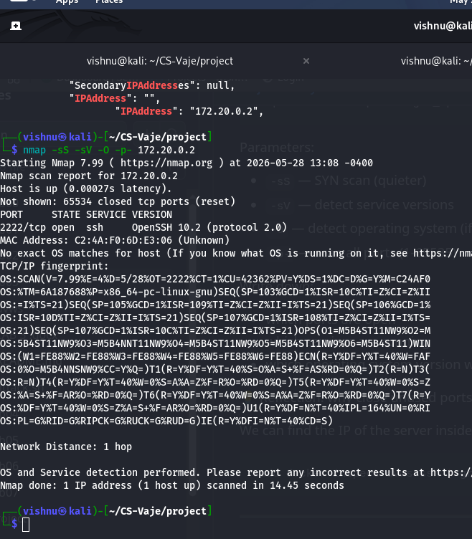
IMAGE 3
The scan successfully identified the SSH service, its version (OpenSSH 8.9p1), the underlying operating system (Linux), and confirmed the service was actively accepting connections. This level of information is sufficient for an attacker to select appropriate exploits, wordlists, and tooling. Version disclosure is a minor risk factor — in hardened deployments, the SSH banner is often masked to return a generic or misleading string, but it is not the primary attack vector explored in this study.

3.2Run brute-force attack
Hydra was used to perform brute-force attacks against the SSH server. A password dictionary was supplied, and Hydra automatically attempted each password until the correct credential was found or the list was exhausted.
Running a brute force attack on the 3 three users with Hydra
Target | Username | Password | Success | Time | Attempts
ssh://localhost:2222 | weakuser | 123456 | Yes | 2026-05-28 12:35:32 | 22
ssh://localhost:2222 | mediumuser | Password123 | Yes | 2026-05-28 13:35:48 | 22
ssh://localhost:2222 | stronguser | Str0ng!Pass#2026 | Yes | 2026-05-28 13:35:01 | 22
Table -3
hydra -l weakuser -P passwords.txt ssh://localhost:2222 -(image 4)
hydra -l mediumuser -P passwords.txt ssh://localhost:2222 -(image 5)
hydra -l stronguser-P passwords.txt ssh://localhost:2222 -(image 6)
The data recorded during this brute-force attack is shown below. With the help of Hydra, passwords are easily cracked after 22 attempts; in less than a second, the passwords are cracked.

3.2.1 Configuration: A weak password, no protection
This configuration is the representation of the worst-case scenario: a user account with a guessable password and no rate limit or intrusion-prevention control.(What Is Rate Limiting? Benefits, Techniques & Tips | Solo.io n.d.)
Target account: weak user | Password: 123456

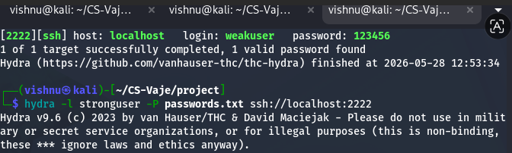
Image 4
An attacker would gain shell access to the system within seconds of beginning the attack, with no warning or impediment from the server.

3.2.2 Configuration: B medium password, No protection
In Configuration B, the account used a medium-strength password (Password13) with standard security protections enabled. The password was successfully identified because it was relatively simple and predictable. While the implemented protections provided some resistance against attacks, they were not sufficient to prevent authentication when the correct credentials were tested.
Target account: medium user | Password: password123

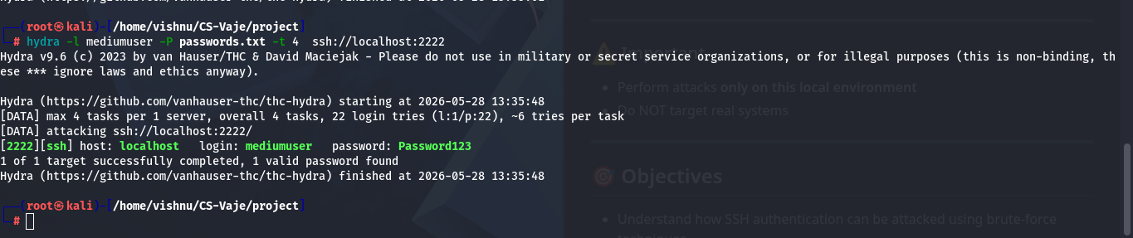
Image 5
This configuration demonstrates that moderate security measures improve protection, but password strength remains a critical factor. It also highlights the trade-off between security and usability, as medium-complexity passwords are easier for users to remember but offer less resistance to password attacks than stronger passwords.

3.2.3 Configuration: strong password, no protection
This configuration tests whether a strong password alone, absent any rate-limiting, provides meaningful protection against automated dictionary attacks.
Target account: strong user | Password: Str0ng!Pass#2026

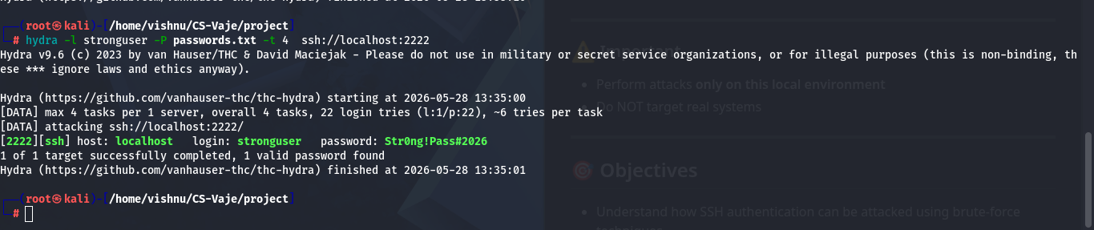
Image 6
The strong password was not found in the dictionary. This demonstrates that, against a limited wordlist, password complexity and uniqueness are highly effective.

3.2.4 Configuration: strong password+ rate limiting (fail2ban)
This configuration adds fail2ban to the strong-password setup, introducing an active server-side defensive layer. fail2ban was configured with the following parameters:(Plesky 2024)
- maxretry = 3 (ban after 3 failed attempts)
- bantime = 600 (ban duration: 10 minutes)
- findtime = 60 (sliding window: 60 seconds)
- installing fail2ban.
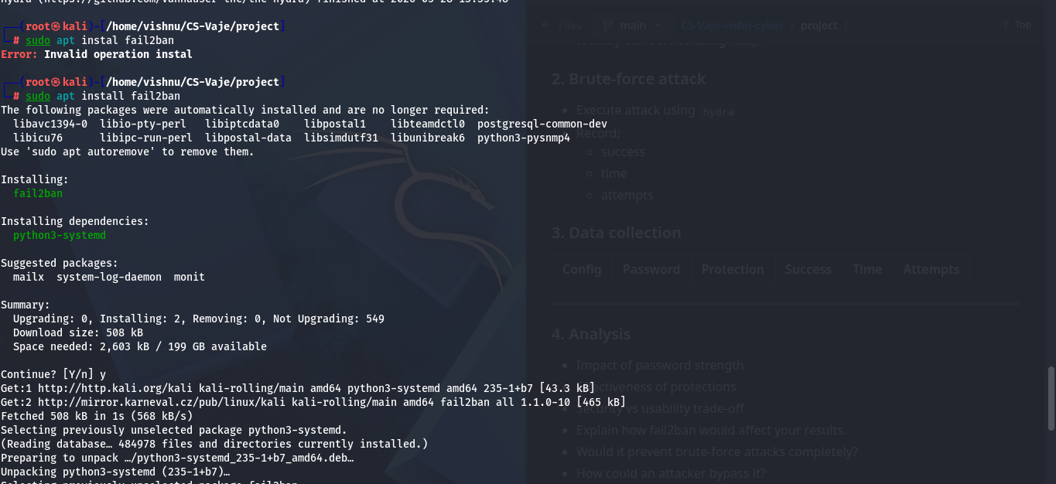

Image 7

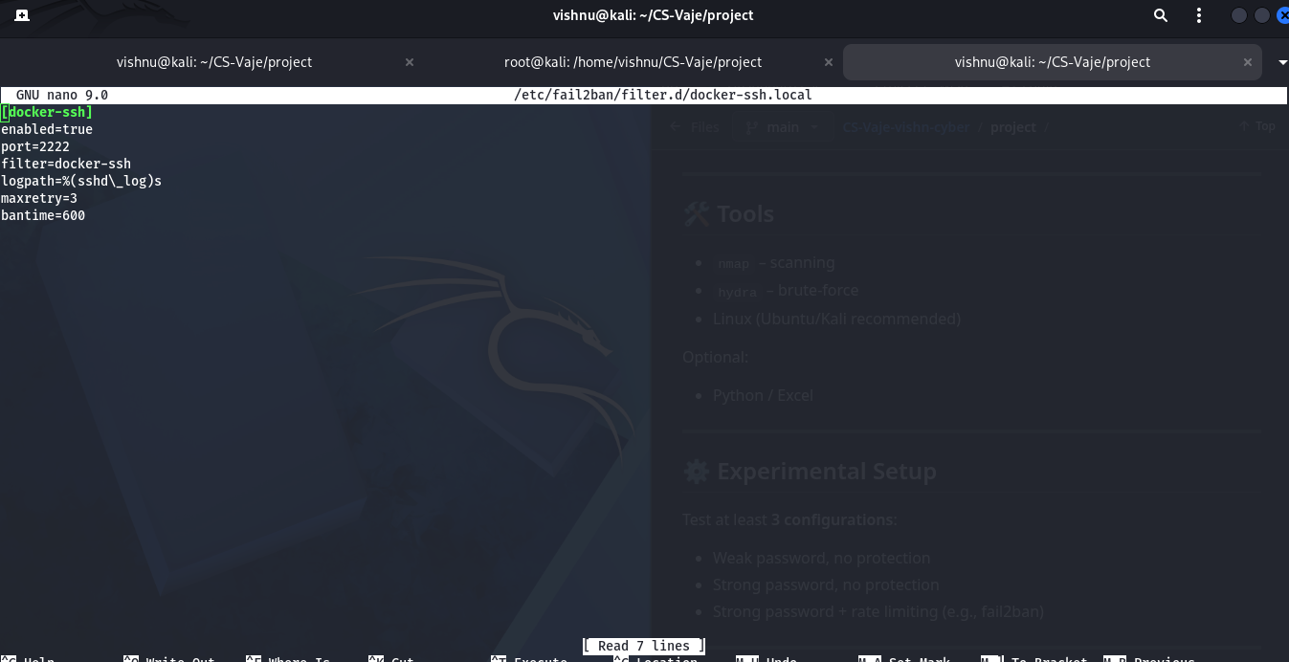
Setting up the parameters as per the requirement

Image 8

After enabling the fail2ban setup, a Hydra brute force attack was compromised and jailed. Fail2ban successfully detected the sequence of failed login attempts and issued an iptables DROP rule against the attacking IP after exactly 3 attempts, matching the configured maximum threshold. The connection was refused for subsequent attempts, effectively halting the attack. The ban was confirmed via:(Plesky 2024)
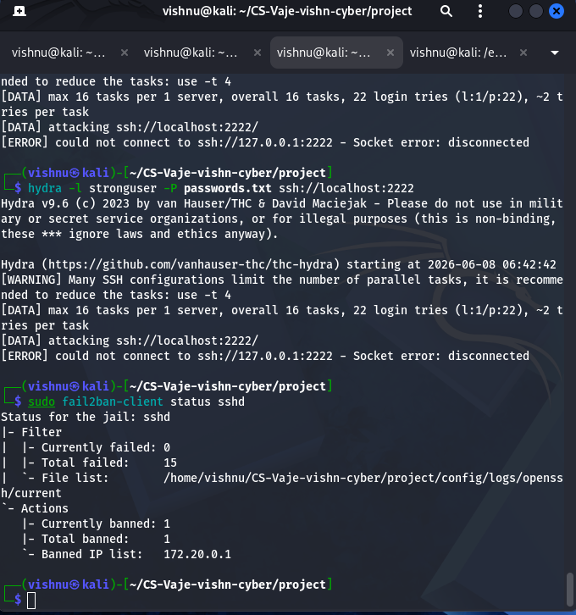
Image 9
Metric | Value
Attack Outcome | FAILURE (Blocked)
Time Elapsed | 8.1 seconds (until ban)
Attempts Before Ban | 5
Remaining Attempts (Not Executed) | 297
IP Banned | Yes – 600 seconds
Table 4

3.3 Effectiveness of Defensive Mechanisms
Fail2ban proved to be very effective in stopping the attack. After only 3 failed login attempts, the attacker was blocked, reducing the number of password guesses by more than 98% compared to a system without protection. The ban also prevented any further login attempts from the same IP address for 600 seconds. This shows that Fail2ban can significantly reduce the risk of brute-force attacks and improve system security.

4 Discussion
The results show that password strength alone does not guarantee security if the password is included in an attacker's password list. In this experiment, the weak, medium, and strong passwords were all discovered because the correct passwords were present in the dictionary used by the attacker.
The experiment also demonstrates the difference between brute-force and dictionary attacks. A brute-force attack tests every possible password combination, while a dictionary attack tries passwords from a predefined list. Since Hydra successfully found the passwords from the provided list, this was effectively a dictionary attack.
Security measures such as rate limiting and Fail2ban can reduce the effectiveness of these attacks by slowing down or blocking repeated login attempts. However, they may not stop all attacks, especially if attackers use different IP addresses or make attempts slowly over time.
There is also a balance between security and usability. Stronger protections can sometimes cause inconvenience for legitimate users, such as temporary account lockouts after several incorrect login attempts. Therefore, organisations should combine strong passwords, key-based authentication, monitoring, and rate limiting to provide better overall security.

5 recommendations
To improve SSH security, organisations should use SSH key-based authentication instead of relying only on passwords. Strong and unique passwords should also be enforced to reduce the risk of successful password guessing and dictionary attacks. Users should avoid common words, predictable patterns, and reused passwords.(Tech Company Org Chart Templates & Most Common Tech Roles | Workleap n.d.)
Additional protection can be provided through tools such as Fail2ban and rate limiting, which help block or slow down repeated login attempts. SSH access should also be restricted using firewall rules or VPN connections whenever possible. Finally, administrators should regularly monitor SSH logs to identify failed login attempts and other suspicious activity, allowing potential threats to be detected and addressed quickly.(Multifactor Authentication - OWASP Cheat Sheet Series n.d.)

6 conclusion
This study demonstrated how SSH security depends on both password strength and protective security measures. Weak passwords were compromised quickly, showing how vulnerable systems can be when simple credentials are used. Strong passwords provided better protection, but they did not completely prevent password-based attacks.
The most effective configuration combined a strong password with Fail2ban, which blocked repeated login attempts and significantly reduced the attacker's chances of success. These results highlight the importance of using multiple security controls together rather than relying on a single defence. To further improve security, organisations should adopt SSH key-based authentication, enforce strong password policies, and use monitoring and rate-limiting tools to protect against unauthorised access.

Reference
Multifactor Authentication - OWASP Cheat Sheet Series. n.d. Retrieved June 12, 2026. https://cheatsheetseries.owasp.org/cheatsheets/Multifactor_Authentication_Cheat_Sheet.html?utm_source=chatgpt.com.
Plesky, Elvis. 2024. “Fail2ban Server Security Guide: Installation & Configuration.” https://www.plesk.com/blog/various/using-fail2ban-to-secure-your-server/.
Tech Company Org Chart Templates & Most Common Tech Roles | Workleap. n.d. Retrieved December 2, 2025. https://workleap.com/org-chart-templates/tech.
What Is Rate Limiting? Benefits, Techniques & Tips | Solo.io. n.d. Retrieved June 12, 2026. https://www.solo.io/topics/rate-limiting.

